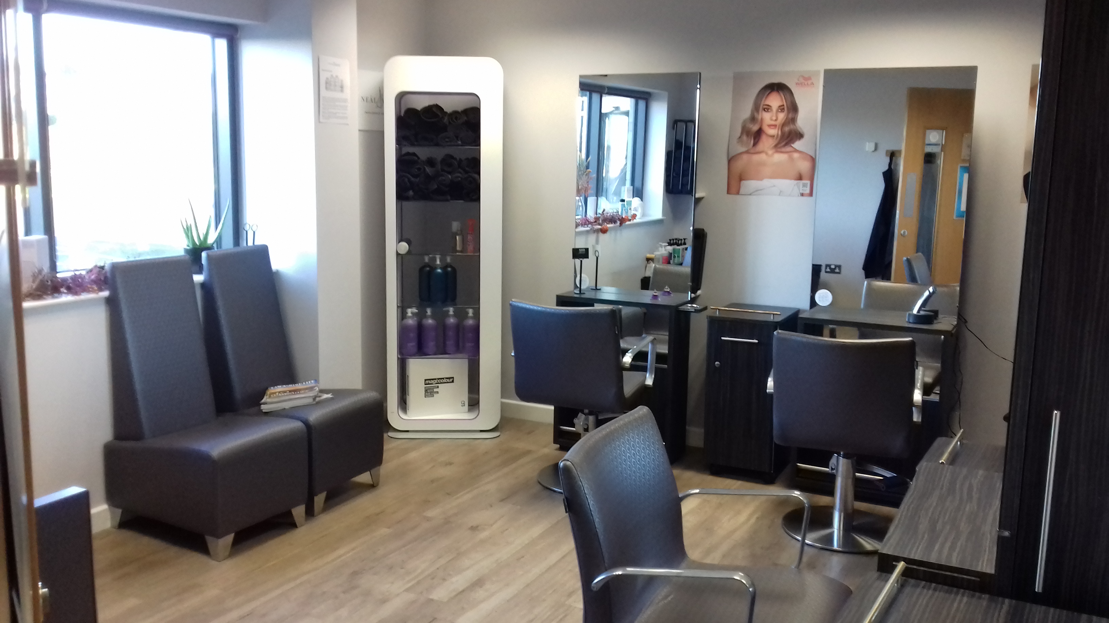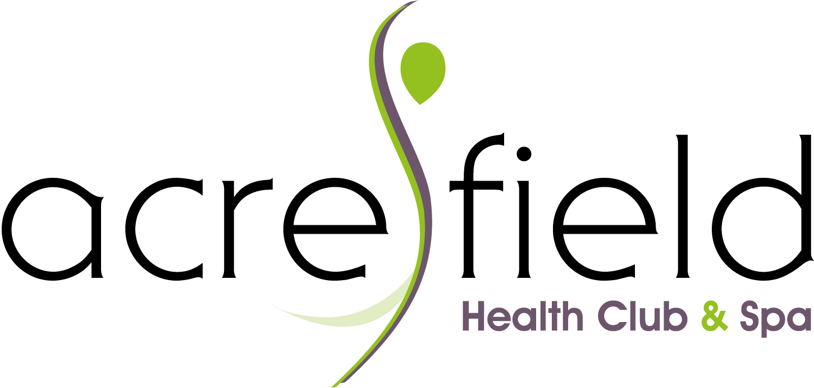

**Local Hair Stylists**

GROW YOUR BUSINESS WITH US

Rent A Chair At Our Professional Hair Studio

WHAT’S INCLUDED

Rent a chair in our well established Hair Studio within a luxury Health Club setting

Expand your business and advertise to our Club Members and visitors

Complimentary on-site parking

The Studio is available Monday - Sunday, days negotiable

WANT TO HEAR MORE?

Please enquire at Reception or E: [membership@acresfieldleisure.co.uk](mailto:membership@acresfieldleisure.co.uk) T: 01995 604975